**New Client Information**

**Client Information:**

Client Name: Click here to enter text. Client Type: Click here to enter text.

**Client Contact:**

Country:Click here to enter text.

Address 1: Click here to enter text.

Address 2: Click here to enter text.

City: Click here to enter text. State/Province: Click here to enter text. Zip: Click here to enter text.

Phone Number: Click here to enter text.

*(Optional)*



**Billing Contact:**

**Technical Contact:** *(optional: if a Technical Contact is listed, the following information is needed)*

First Name: Click here to enter text.

Last Name: Click here to enter text.

Phone Number: Click here to enter text.

*(Optional)*

Email address: Click here to enter text.

First Name: Click here to enter text.

Last Name: Click here to enter text.

Phone Number: Click here to enter text.

*(Optional)*

Email address: Click here to enter text.

**Note: This information will be available to users in Collaborati as seen in the sample below:**

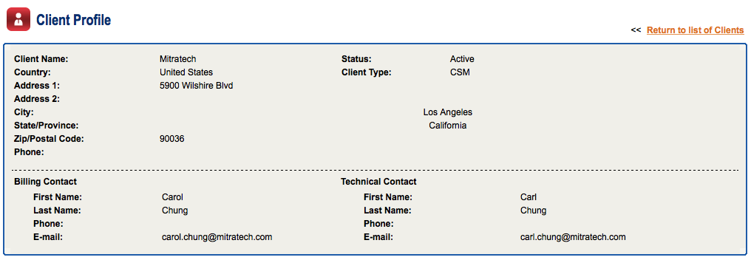





*Some clients have created an email distribution list, such as* [*MitratechHostingNotifications@yourcompany.com*](mailto:MitratechHostingNotifications@yourcompany.com) *to allow notifications to go to several different people. This would be maintained by your internal IT department. If any changes need to be made to the people/contacts, it can be easily changed by your company without the need to contact us to do so.*

*We occasionally send out notifications regarding scheduled down time for Collaborati (this is usually for upgrades or similar notifications). As a best practice, we recommend stopping the sync with Collaborati when this takes place. Add the appropriate email address in order to receive notifications when this occurs.*

Contact Name: Click here to enter text. Email address: Click here to enter text.

**Collaborati Hosted Notifications Contact:**